1-BIT ALU PERFORMING AND, OR, XOR, CARRY, DIFFERENCE, BORROW, INVERTER, and PASSTHROUGH USING CMOS LOGIC
The inputs be:
->A: First operand bit.
->B: Second operand bit.
Outputs:
->Y: Output operand bit.
Select lines:
->S0,S1,S2
1) AND OPERATION:
Here the AND gate is build using the CMOS logic. The AND operation performs when the select lines of the MUX is given as 000.
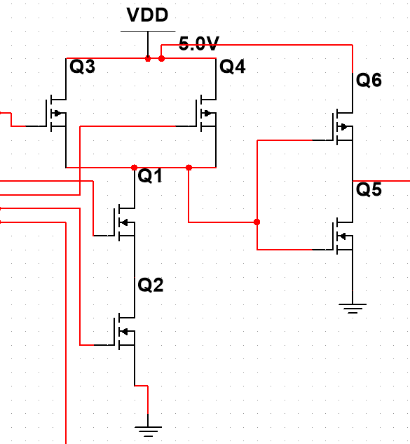
LOGIC DIAGRAM:

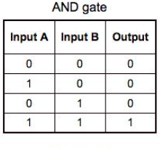
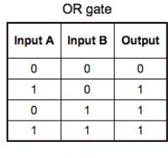
TRUTH TABLE:

2) OR OPERATION:
Here the OR gate is build using the CMOS logic. The OR operation performs when the select lines of the MUX is given as 001.
LOGIC DIAGRAM:
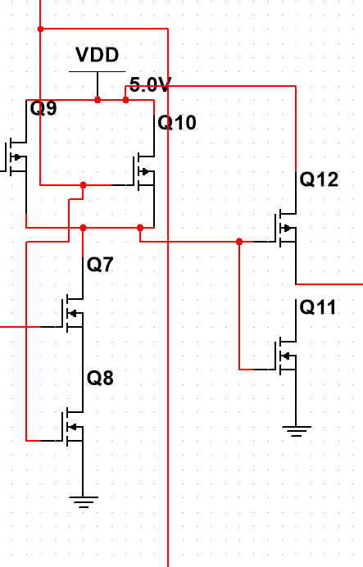
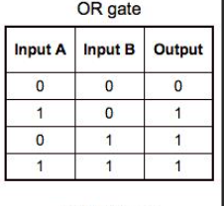
TRUTH TABLE:

3) XOR OPERATION:
Here the XOR gate is build using the CMOS logic. The XOR operation performs when the select lines of the MUX is given as 010.
LOGIC DIAGRAM:
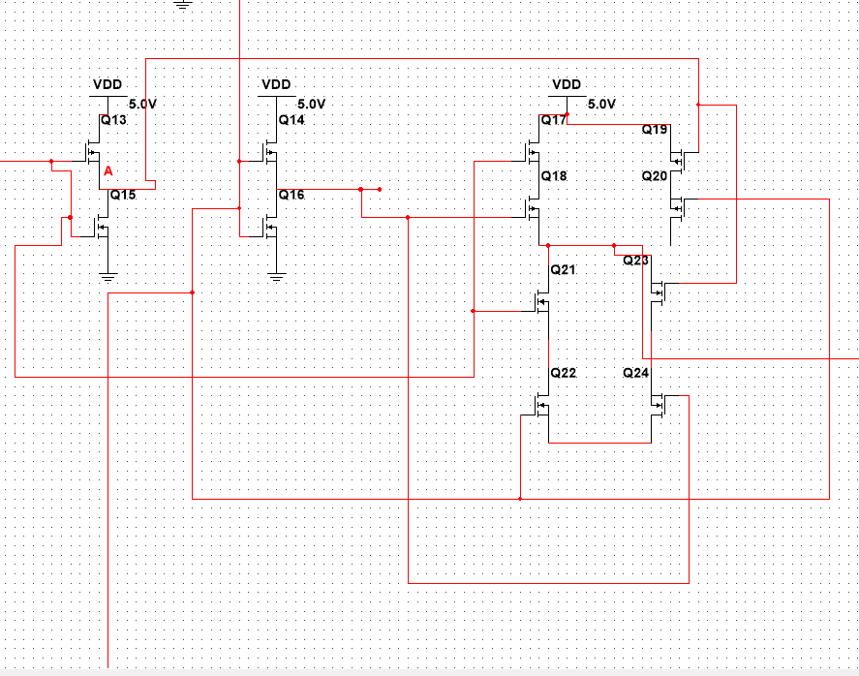

TRUTH TABLE:
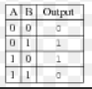
4)CARRY OPERATION:
Here the CARRY operation is it the one of the output of the Half adder circuit so as we already know that the inputs of the circuit is A,B so we can Generate the carry from the Half adder circuit.
CARRY=A AND B
The above Carry circuit can be implemented through the CMOS logic. The CARRY operation performs when the select lines of the MUX is given as 011.
LOGIC DIAGRAM:
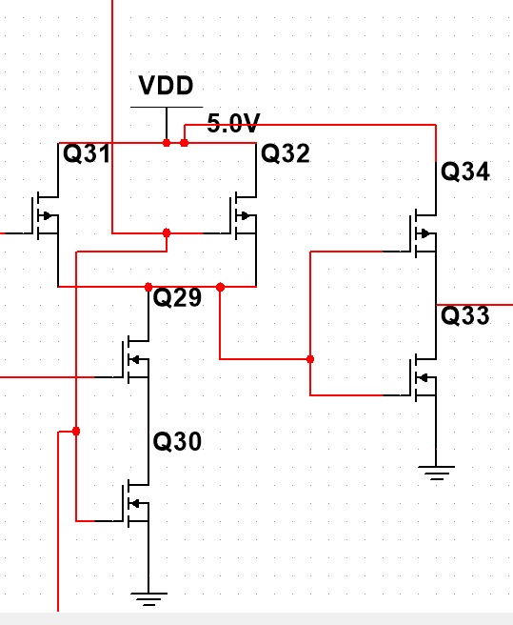
TRUTH TABLE:
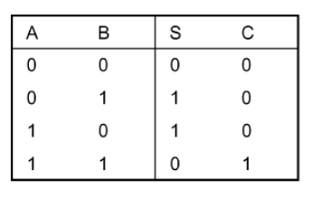
5) DIFFERENCE OPERATION:
Here the DIFFERENCE operation is it the one of the output of the Half subtractor circuit so as we already know that the inputs of the circuit is A,B so we can Generate the difference from the Half subtractor circuit.
DIFFERENCE = A XOR B
The above Difference circuit can be implemented through the CMOS logic. The DIFFERENCE operation performs when the select lines of the MUX is given as 100.
LOGIC DIAGRAM:
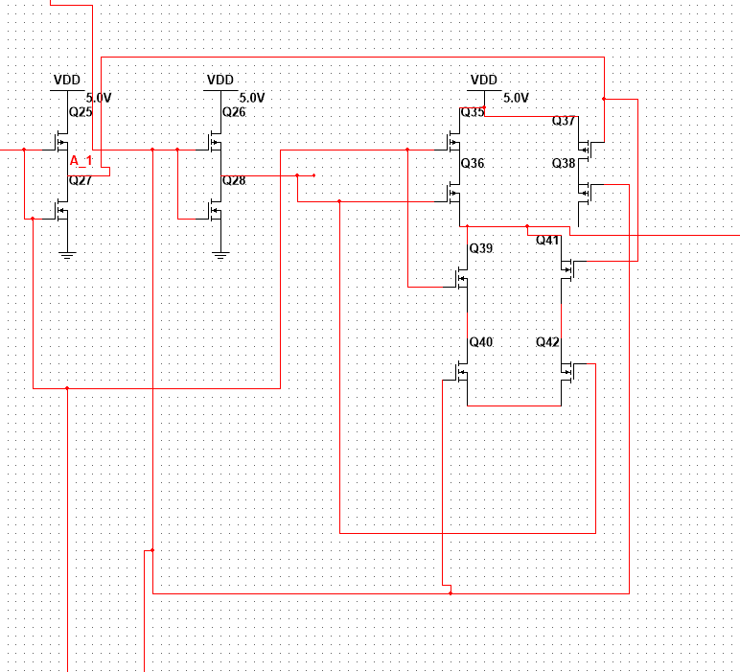

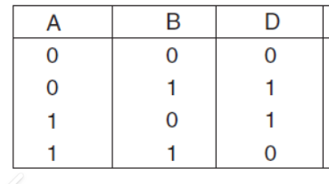
TRUTH TABLE:

6) BORROW OPERATION:
Here the BORROW operation is it the one of the outputs of the Half subtractor circuit so as we already know that the inputs of the circuit is A,B so we can Generate the borrow from the Half subtractor circuit.
BORROW = ~A AND B
The above Borrow circuit can be implemented through the CMOS logic. The BORROW operation performs when the select lines of the MUX is given as 101.
LOGIC DIAGRAM:
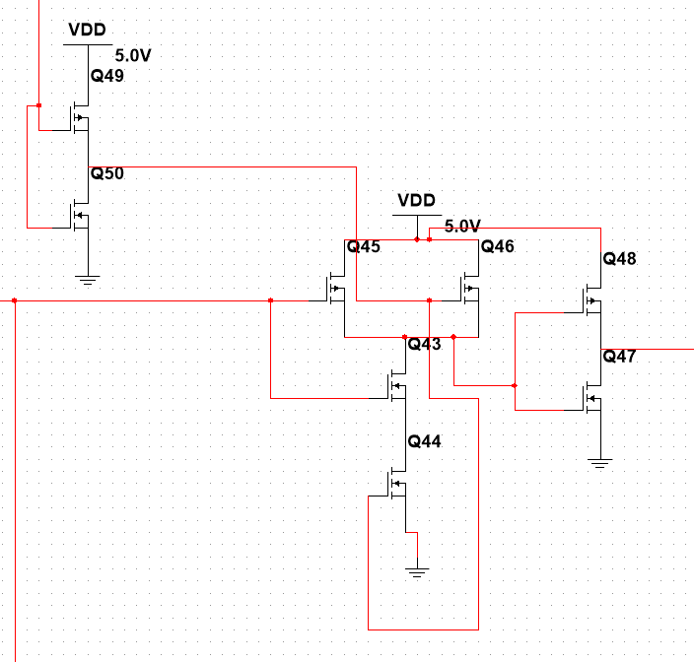

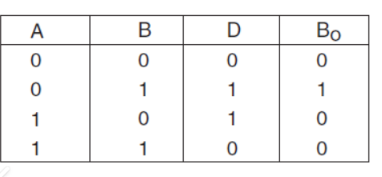
TRUTH TABLE:

9) INVERTER OPERATION:
Here the NOT gate is build using the CMOS logic. The NOT operation performs when the select lines of the MUX is given as 110.
LOGIC DIAGRAM:
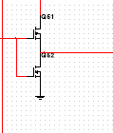

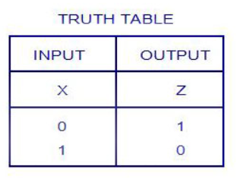
TRUTH TABLE:

8) PASSTHROUGH OPERATION:
Here the BUFFER gate is build using the CMOS logic. The BUFFER operation performs when the select lines of the MUX is given as 111.
LOGIC DIAGRAM:
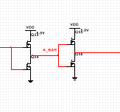
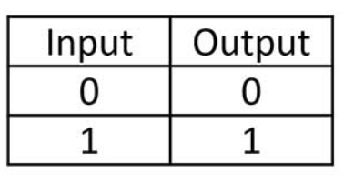
TRUTH TABLE:

- ALL these operations are connected to the MUX and the output is connected to a LED with the help of a resistor and LED glows when the output is high otherwise low.
